**4.n** User Interface Design

(Introduction)

**4.n.1** Correctness Tutorial Page

The Correctness tutorial page is shown in Figure N, and the interface design would be divided into two parts: Basic Operation for Each Page and Pages Design.

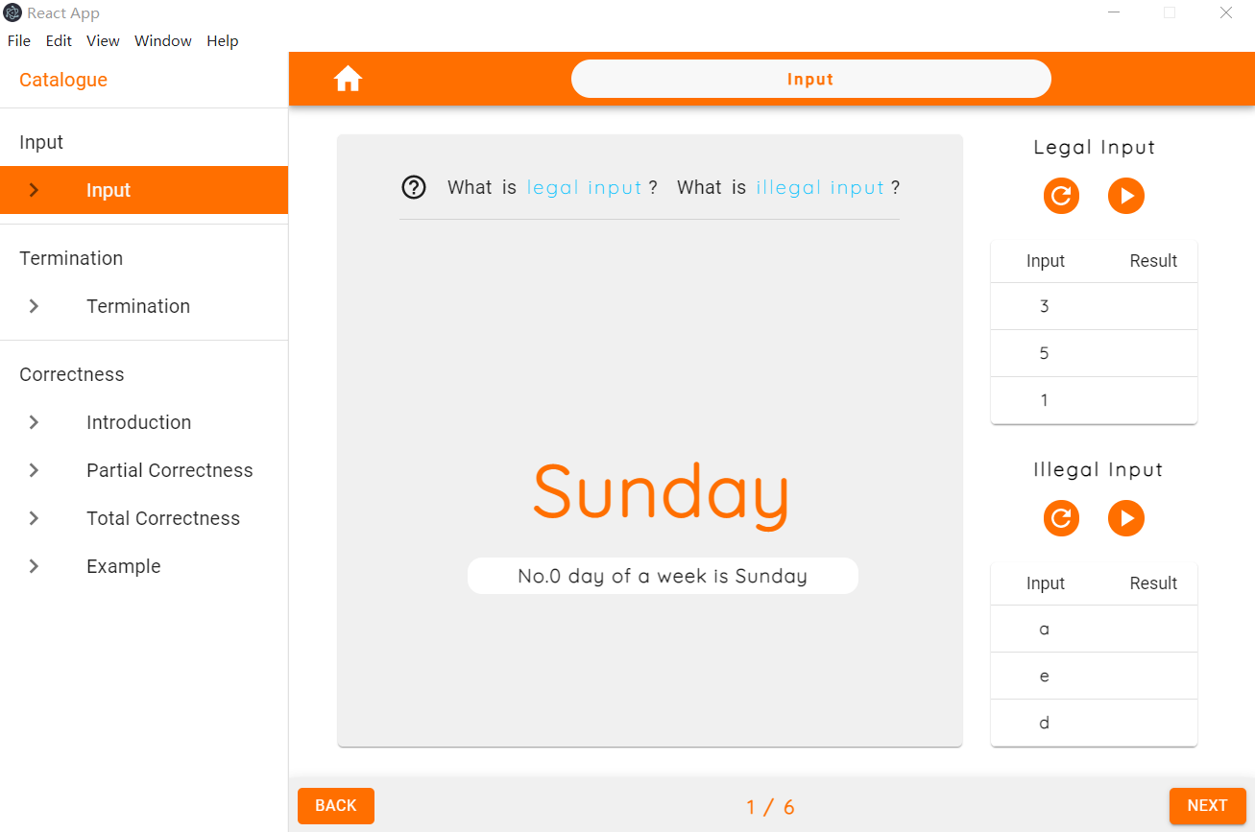

1. Basic Operation for Each Page
   * Page Button Group

The page button group is on the left-hand side of the software, and it is used to select the page. They are Input, Termination, Introduction, Partial Correctness, Total Correctness, and Example. When users click one of the buttons, the corresponding page is chosen, and this button will be highlighted in orange color.

* + Page Jump Panel

The page jump panel is on the bottom of the software, and it is used to go to the last or next page. In the middle, it shows the current page number. Users can click "back" to get the previous page or click "next" to get the next page on both sides. For the first page, users cannot use the "back" button, while for the last page, users cannot use the "next" button.

1. Pages Design
   1. Input Page

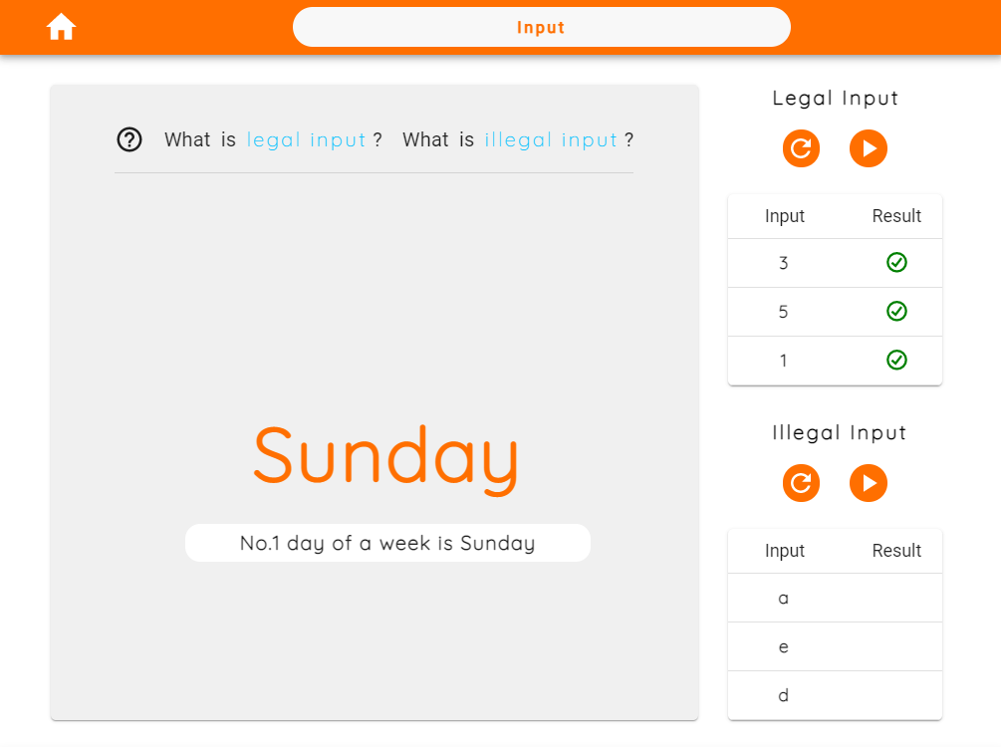

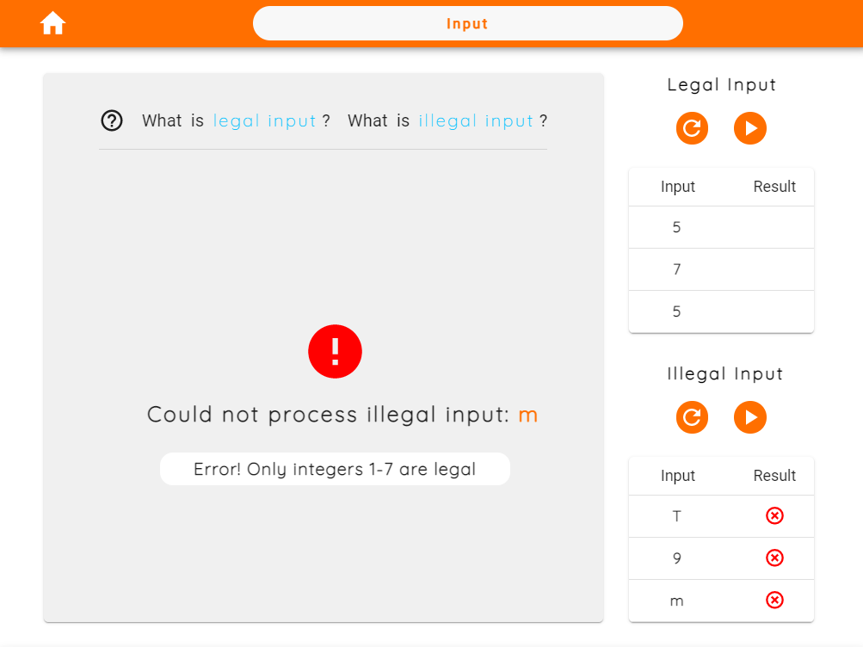

* + Legal and Illegal Input Operation Panel

The legal and illegal input operation panel is on the right-hand side of the input page. They both consist of a shuffle button, a play button, and an input and result table.

The table is under two buttons. It has two columns: input and result, and three rows for information. Its input depends on "shuffle" and "play" buttons. When users click the shuffle button, the input column will create input. When users click the play button, the result column will generate a result.

The shuffle button is on the top of the input and result table, and the play button's left. It is used to create a random number. If users click legal(illegal) shuffle, the compiler will display three sets of legal(illegal) inputs in the legal(illegal) table.

The play button is on the top of the input and result table, and the shuffle button's right. It is used to play the animation. If users click the legal play button, the compiler will recognize legal numbers on the table's input column one by one. Simultaneously, the complier will tick the result column of the Table one by one because the input is legal. Additionally, on the left-hand side of the page, it will display the corresponding animation.

On the contrary, if users click the illegal play button, the compiler will recognize illegal numbers on the table's input column one by one. In contrast, the compiler will put the result column of the table cross because the input is illegal. Additionally, the left side will show an error because the input is illegal.

* + Animation

The animation is on the left-hand side of the input page. It is used to display a specific algorithm's result animation. For example, if the legal table has a "1" input, the animation will show "Sunday" because Sunday is the first day of a week after clicking the play button.

* + Explanation Link

The explanation link is on the top of the animation. It is used to explain what legal input is and what illegal input is. If users click it, a pop-up window will appear in the center of the page. This window uses a way of combining pictures and text to explain the specific algorithm, legal input, and illegal input.

* 1. Termination Page
  + Animation

There is two animation part on the termination page, and they are on the top. The left one is an animation that is terminable. The right one is not terminable, and it will play all-time unless users click the play button to stop it. They are both corresponding to the algorithm under them.

* + Algorithm Highlighting

The algorithm highlighting is at the bottom of the page. It is used to highlight which row is working. According to the animation, the corresponding row will turn orange to help users understand.

* 1. Partial and Total Correctness Page
  + Explanation

The partial and total correctness pages are both contain an explanation part, which on the left. It is used for explaining the definition of correctness.

* + Figure

The partial and total correctness pages are both contain a figure, which on the right. It is used to help users to understand the explanation.

* 1. Example
  + Prompt backdrop

The prompt box appears as soon as users click the "Example" page button. It is a backdrop that contains a prompting. It is used to prompt users to enter the legal input when they run the algorithm.

* + Algorithm Panel

After confirming the prompting, the algorithm panel is on the bottom of the page. It is used to provide three different types of an algorithm for users to understand what partial correctness is and what total correctness is and what not terminal and correct algorithm is. After entering a number on the operation panel, users can click each algorithm to run and see the operation panel's output.

* + Operation Panel

After confirming the prompting, the algorithm panel is on the top of the page. It is used to allow users to enter input and see the output of three algorithms on the algorithm panel.

The panel has three parts corresponding to the algorithms: input expected output and actual output. Firstly, Input parts for users to enter input, and this input will be written into the compiling algorithm. Secondly, expected output parts for users to see what an algorithm should output. Finally, the Actual output part for users to see what an algorithm output.